Diameter of a Cylinder
# Source: AI Source: Provided by: [Data Path: Persons Table -> ID Column: 1, Name_En Column: Motasem Essam] -> From: [ChatGPT] on [7/25/2026]
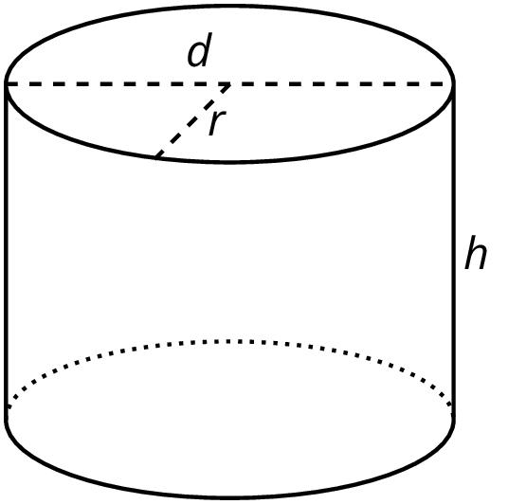
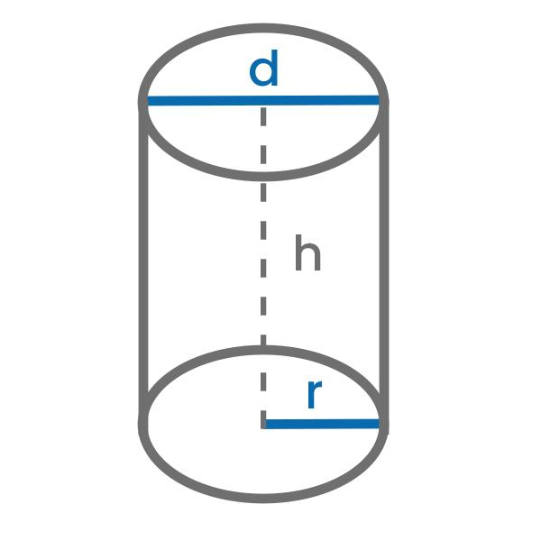
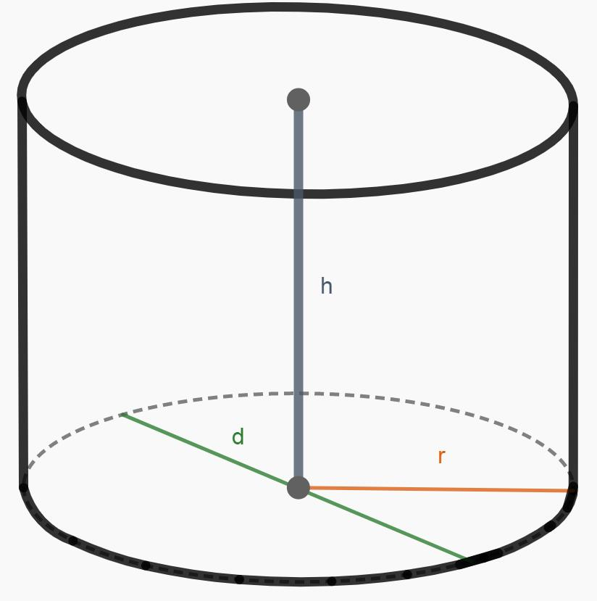

Definition
# Source: AI Source: Provided by: [Data Path: Persons Table -> ID Column: 1, Name_En Column: Motasem Essam] -> From: [ChatGPT] on [7/25/2026]
The diameter of a cylinder is the diameter of its circular base: a straight line segment passing through the center of the circle and joining two points on its circumference.
For a circular cylinder with congruent bases, the top and bottom bases have the same diameter.
The diameter is twice the radius of the circular base.
$$\boxed{d=2r}$$

Simple Definition
# Source: AI Source: Provided by: [Data Path: Persons Table -> ID Column: 1, Name_En Column: Motasem Essam] -> From: [ChatGPT] on [7/25/2026]
The diameter is the full width of a cylinder's circular base measured through its center.
It is the longest straight-line distance between two points on the circumference of the base.

Geometric Representation and Components
# Source: AI Source: Provided by: [Data Path: Persons Table -> ID Column: 1, Name_En Column: Motasem Essam] -> From: [ChatGPT] on [7/25/2026]
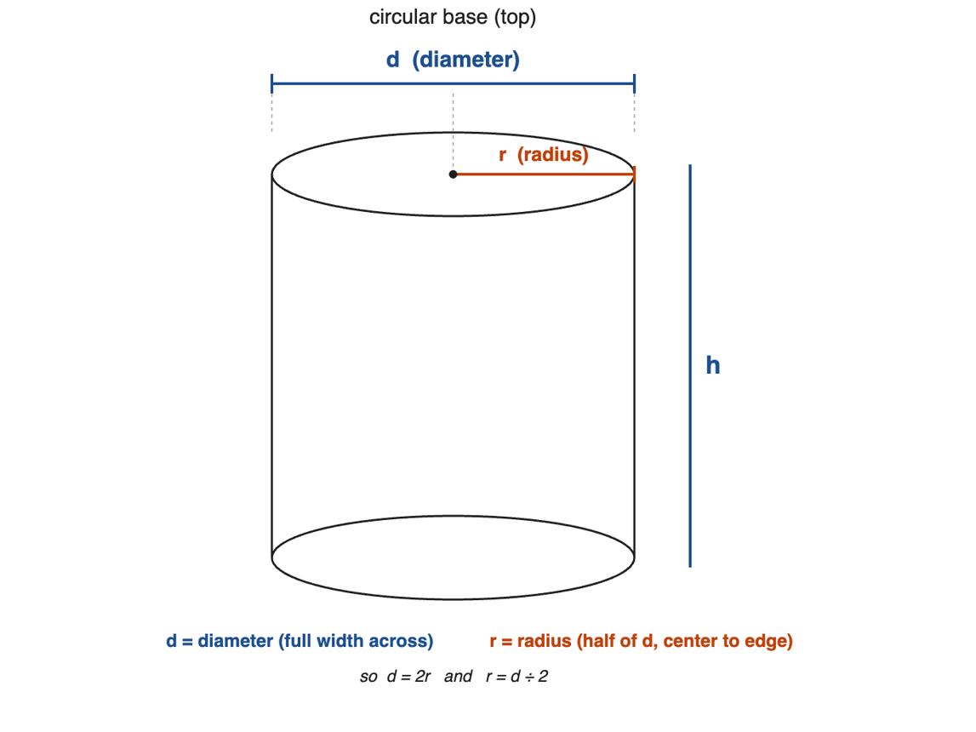
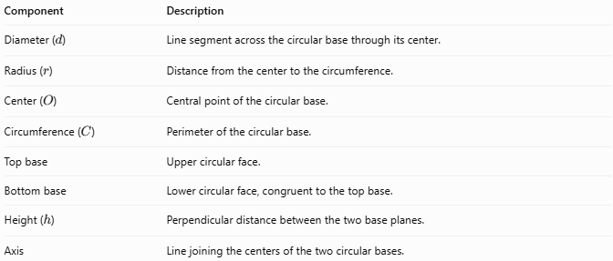
Component | Description
Diameter ($d$) | Line segment across the circular base through its center.
Radius ($r$) | Distance from the center to the circumference.
Center ($O$) | Central point of the circular base.
Circumference ($C$) | Perimeter of the circular base.
Top base | Upper circular face.
Bottom base | Lower circular face, congruent to the top base.
Height ($h$) | Perpendicular distance between the two base planes.
Axis | Line joining the centers of the two circular bases.

Types and Classification

Base Diameter
# Source: AI Source: Provided by: [Data Path: Persons Table -> ID Column: 1, Name_En Column: Motasem Essam] -> From: [ChatGPT] on [7/25/2026]
The diameter measured across either circular base. For a circular cylinder with congruent bases:
$$d_{\text{top}}=d_{\text{bottom}}=d$$

Outer Diameter
# Source: AI Source: Provided by: [Data Path: Persons Table -> ID Column: 1, Name_En Column: Motasem Essam] -> From: [ChatGPT] on [7/25/2026]
For a hollow cylinder or pipe, the outer diameter measures across the outside circular boundary through the center.
$$d_{\text{outer}}=2R$$
Here, $R$ is the outer radius.

Inner Diameter
# Source: AI Source: Provided by: [Data Path: Persons Table -> ID Column: 1, Name_En Column: Motasem Essam] -> From: [ChatGPT] on [7/25/2026]
The inner diameter measures across the inside opening of a hollow cylinder.
$$d_{\text{inner}}=2r$$
Here, $r$ is the inner radius.

Diameter of a Solid Cylinder
# Source: AI Source: Provided by: [Data Path: Persons Table -> ID Column: 1, Name_En Column: Motasem Essam] -> From: [ChatGPT] on [7/25/2026]
For a solid circular cylinder, the diameter is the full width of its base. The solid cylinder has no inner diameter unless a hole or hollow region is introduced.

Mathematical Formulas

Diameter from the Radius
# Source: AI Source: Provided by: [Data Path: Persons Table -> ID Column: 1, Name_En Column: Motasem Essam] -> From: [ChatGPT] on [7/25/2026]
Since the diameter consists of two radii:
$$\boxed{d=2r}$$

Radius from the Diameter
# Source: AI Source: Provided by: [Data Path: Persons Table -> ID Column: 1, Name_En Column: Motasem Essam] -> From: [ChatGPT] on [7/25/2026]
$$\boxed{r=\frac{d}{2}}$$

Diameter from the Circumference
# Source: AI Source: Provided by: [Data Path: Persons Table -> ID Column: 1, Name_En Column: Motasem Essam] -> From: [ChatGPT] on [7/25/2026]
The circumference of a circular base is:
$$C=πd$$
Therefore:
$$\boxed{d=\frac{C}{π}}$$

Diameter from the Base Area
# Source: AI Source: Provided by: [Data Path: Persons Table -> ID Column: 1, Name_En Column: Motasem Essam] -> From: [ChatGPT] on [7/25/2026]
The area of a circular base is:
$$A_{B}=πr^{2}$$
Substituting $r=d/2$:
$$A_{B}=π{\left(\frac{d}{2}\right)}^{2}$$
Solving for the diameter:
$$\boxed{d=2\sqrt{\frac{A_{B}}{π}}}$$

Diameter from the Volume
# Source: AI Source: Provided by: [Data Path: Persons Table -> ID Column: 1, Name_En Column: Motasem Essam] -> From: [ChatGPT] on [7/25/2026]
The volume of a circular cylinder is:
$$V=πr^{2}h$$
Since $r=d/2$:
$$V=π{\left(\frac{d}{2}\right)}^{2}h$$
Therefore:
$$\boxed{d=2\sqrt{\frac{V}{πh}}}$$

Diameter from the Lateral Surface Area
# Source: AI Source: Provided by: [Data Path: Persons Table -> ID Column: 1, Name_En Column: Motasem Essam] -> From: [ChatGPT] on [7/25/2026]
For a right circular cylinder:
$$A_{L}=πdh$$
Rearranging:
$$\boxed{d=\frac{A_{L}}{πh}}$$

Diameter of a Hollow Cylinder
# Source: AI Source: Provided by: [Data Path: Persons Table -> ID Column: 1, Name_En Column: Motasem Essam] -> From: [ChatGPT] on [7/25/2026]
For a hollow cylinder:
$$\boxed{d_{\text{outer}}=2R}$$
$$\boxed{d_{\text{inner}}=2r}$$
The difference between the outer and inner diameters is twice the wall thickness:
$$\boxed{d_{\text{outer}}-d_{\text{inner}}=2t}$$
where $t=R-r$.

Worked Examples
# Source: AI Source: Provided by: [Data Path: Persons Table -> ID Column: 1, Name_En Column: Motasem Essam] -> From: [ChatGPT] on [7/25/2026]
Example 1 — Find the Diameter from the Radius
A cylinder has a base radius of $6\text{ cm}$. Find its diameter.
Solution:
$$d=2r$$
$$d=2\left(6\right)$$
$$\boxed{d=12\text{ cm}}$$
Example 2 — Find the Diameter from the Circumference
A cylinder's circular base has a circumference of $30π\text{ cm}$. Find its diameter.
Solution:
$$d=\frac{C}{π}$$
$$d=\frac{30π}{π}$$
$$\boxed{d=30\text{ cm}}$$
Example 3 — Find the Diameter from the Base Area
A cylinder has a base area of $49π{\text{ m}}^{2}$. Find its diameter.
Solution:
$$d=2\sqrt{\frac{A_{B}}{π}}$$
$$d=2\sqrt{\frac{49π}{π}}$$
$$d=2\sqrt{49}=2\left(7\right)$$
$$\boxed{d=14\text{ m}}$$
Example 4 — Find the Diameter from the Volume
A cylinder has a volume of $144π{\text{ cm}}^{3}$ and a height of $16\text{ cm}$. Find its diameter.
Solution:
$$d=2\sqrt{\frac{V}{πh}}$$
$$d=2\sqrt{\frac{144π}{16π}}$$
$$d=2\sqrt{9}$$
$$\boxed{d=6\text{ cm}}$$
Example 5 — Find the Wall Thickness from the Diameters
A hollow cylindrical pipe has an outer diameter of $20\text{ mm}$ and an inner diameter of $14\text{ mm}$. Find its wall thickness.
Solution:
The wall thickness is half the difference between the diameters:
$$t=\frac{d_{\text{outer}}-d_{\text{inner}}}{2}$$
$$t=\frac{20-14}{2}=\frac{6}{2}$$
$$\boxed{t=3\text{ mm}}$$

How the Diameter Affects a Cylinder
# Source: AI Source: Provided by: [Data Path: Persons Table -> ID Column: 1, Name_En Column: Motasem Essam] -> From: [ChatGPT] on [7/25/2026]
For a right circular cylinder with a fixed height $h$, its volume and lateral surface area can be expressed directly in terms of diameter.
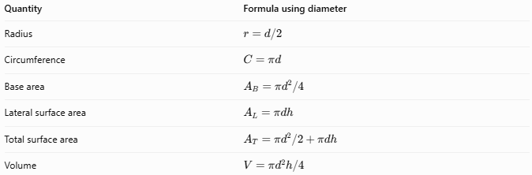
Quantity | Formula using diameter
Radius | $$r=d/2$$
Circumference | $$C=πd$$
Base area | $$A_{B}=πd^{2}/4$$
Lateral surface area | $$A_{L}=πdh$$
Total surface area | $$A_{T}=πd^{2}/2+πdh$$
Volume | $$V=πd^{2}h/4$$
If the diameter doubles while the height remains constant:
- The circumference doubles.
- The base area becomes four times larger.
- The lateral surface area doubles.
- The volume becomes four times larger.

Diameter Compared with Related Measurements
# Source: AI Source: Provided by: [Data Path: Persons Table -> ID Column: 1, Name_En Column: Motasem Essam] -> From: [ChatGPT] on [7/25/2026]
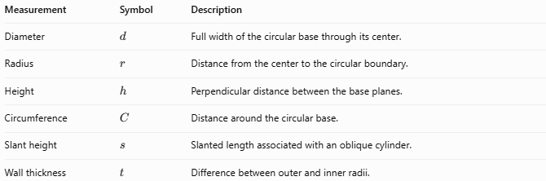
Measurement | Symbol | Description
Diameter | $$d$$ | Full width of the circular base through its center.
Radius | $$r$$ | Distance from the center to the circular boundary.
Height | $$h$$ | Perpendicular distance between the base planes.
Circumference | $$C$$ | Distance around the circular base.
Slant height | $$s$$ | Slanted length associated with an oblique cylinder.
Wall thickness | $$t$$ | Difference between outer and inner radii.
Important distinction: The diameter is a measurement across the circular base, while the height measures the distance between the base planes.

Applications
# Source: AI Source: Provided by: [Data Path: Persons Table -> ID Column: 1, Name_En Column: Motasem Essam] -> From: [ChatGPT] on [7/25/2026]
The diameter is important when measuring or designing:
- Pipes and tubes: determining opening size and wall thickness.
- Cans and containers: determining base width and storage capacity.
- Water tanks: calculating volume from diameter and height.
- Machine components: specifying cylindrical shafts, rollers, and bearings.
- Construction: measuring cylindrical columns and concrete piles.
- Manufacturing: selecting drill bits, fittings, and cylindrical parts.
For hollow pipes, always distinguish the inner diameter from the outer diameter because they describe different dimensions.

Key Points
# Source: AI Source: Provided by: [Data Path: Persons Table -> ID Column: 1, Name_En Column: Motasem Essam] -> From: [ChatGPT] on [7/25/2026]
- The diameter passes through the center of a circular base.
- The diameter is twice the radius: $d=2r$.
- The radius is half the diameter: $r=d/2$.
- The diameter can be calculated from circumference, base area, volume, or lateral surface area.
- Diameter is measured in linear units, such as millimetres, centimetres, or metres.
- A hollow cylinder has both an inner diameter and an outer diameter.
- For a circular cylinder with congruent bases, both bases have the same diameter.

Conclusion
# Source: AI Source: Provided by: [Data Path: Persons Table -> ID Column: 1, Name_En Column: Motasem Essam] -> From: [ChatGPT] on [7/25/2026]
The diameter of a cylinder is the full width of its circular base measured through the center. It is one of the fundamental dimensions used to calculate the circumference, base area, lateral surface area, total surface area, and volume of a cylinder.
The most important relationship is:
$$\boxed{d=2r}$$
When the cylinder's height and volume are known, the diameter can also be calculated using:
$$\boxed{d=2\sqrt{\frac{V}{πh}}}$$

